**Ideation Phase**

**Empathize & Discover**

| Date | 26-06-2025 |
| --- | --- |
| Team ID | LTVIP2025TMID59448 |
| Project Name | ShopSmart |
| Maximum Marks | 4 Marks |

**Empathy Map Canvas:**

An empathy map is a simple, easy-to-digest visual that captures knowledge about a user’s behaviours and attitudes.

It is a useful tool that helps teams better understand their users.

Creating an effective solution requires understanding the true problem and the person who is experiencing it. The exercise of creating the map helps participants consider things from the user’s perspective along with their goals and challenges.

**Example:**

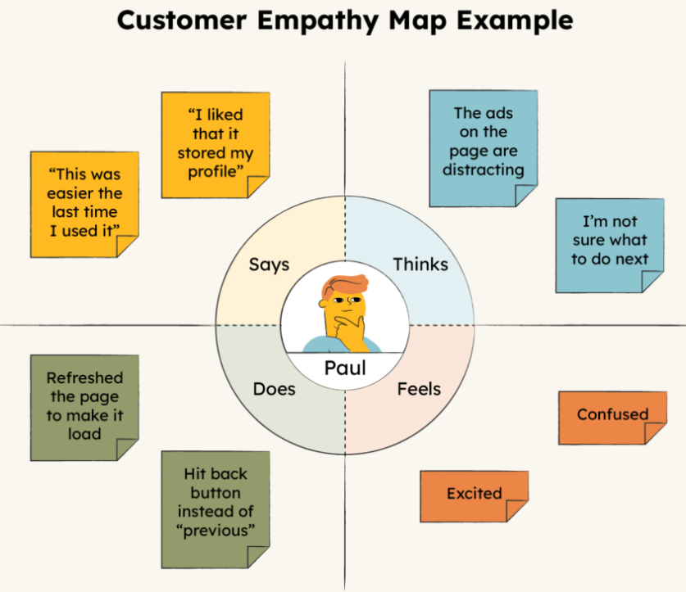

Certainly! Based on your starting line, here's a completed version:

**The purpose of this project is to provide a user-friendly digital solution that connects patients with healthcare professionals efficiently. It ensures:**

1. Easy registration and login for patients and doctors.
2. Smooth appointment booking and management.
3. Secure communication and data sharing between users.
4. Real-time updates on appointment status and availability.
5. A centralized system for doctors to manage their schedules.

Sure! Here's a similar line tailored for **ShopSmart**:

**The purpose of this project is to provide a user-friendly digital platform that connects customers with grocery sellers efficiently. It ensures:**

1. Easy product browsing and seamless online shopping.
2. Quick and secure checkout and payment process.
3. Smooth management of orders and inventory for sellers.
4. Safe handling of customer data and transactions.
5. A responsive system that enhances the overall shopping experience.

**Problem Statement:** In today’s fast-paced world, traditional grocery shopping can be time-consuming and inconvenient, especially for individuals with busy schedules or limited access to local stores. Existing online solutions often lack user-friendliness, real-time inventory updates, or efficient order management for sellers. There is a need for a digital platform that simplifies grocery shopping for customers while providing reliable tools for sellers and administrators to manage products, orders, and user interactions effectively.

Sure! Here's an **Empathy Map Canvas** tailored for **ShopSmart – Your Digital Grocery Store Experience**:

### **Problem Statement:**

Customers often struggle with traditional grocery shopping due to long queues, limited store hours, and lack of real-time product availability, leading to frustration and wasted time.

### **How Might We:**

**How might we enable customers to shop for groceries easily and efficiently from the comfort of their home?**

### **Empathy Map Canvas**

**Says:** “I wish I could order groceries online without going to the store.”

**Thinks:** “Why can’t I see what’s in stock before I plan my meals?”

**Feels:** Frustrated, stressed by time-consuming store visits and out-of-stock items.

**Does:** Browses multiple apps or websites, visits stores in person, checks availability manually.

Let me know if you’d like a visual version or need it adapted for sellers or admins too!

Certainly! Here's a simple **Empathy Map Canvas** for **ShopSmart – Your Digital Grocery Store Experience** that you can copy and paste into your documentation:

### **🧠 Empathy Map Canvas – Customer Perspective (ShopSmart)**

| **SAYS** | **THINKS** |
| --- | --- |
| “I wish I didn’t have to go to the store.” | “Will my favorite items be in stock today?” |
| “This app should be easier to use.” | “I hope my order is delivered on time.” |
| “Why do I need to enter my address every time?” | “Is my payment information secure?” |

| **DOES** | **FEELS** |
| --- | --- |
| Browses products online | Frustrated by confusing interfaces |
| Adds items to cart, places order | Anxious about product availability |
| Tracks delivery or calls support if delayed | Relieved when order is delivered correctly |